**ASSIGNMENT 1**

**Submitted by:**

**Lavanya Lavanya**

**Student ID: 22077323**

**Submitted to:**

**Professor: Nawaz Chowdhury**

**Subject: Programming Paradigms**

**Course code: CSD 211**

Honesty Statement: “I declare that this submission is my work in compliance with Sault College Academic Policies.”

**Due date: 12 January 2024**

Contents

Lab Instructions 5

Step 1: 5

Step 2: 7

Figure 1:Created the Calculator 5

Figure 2:Calculator Code 6

Figure 3:F# Code 7

Figure 4:f# output 8

# **Lab Instructions**

## Step 1:

1. Create a scientific calculator using ASP.NET Web Forms.

.

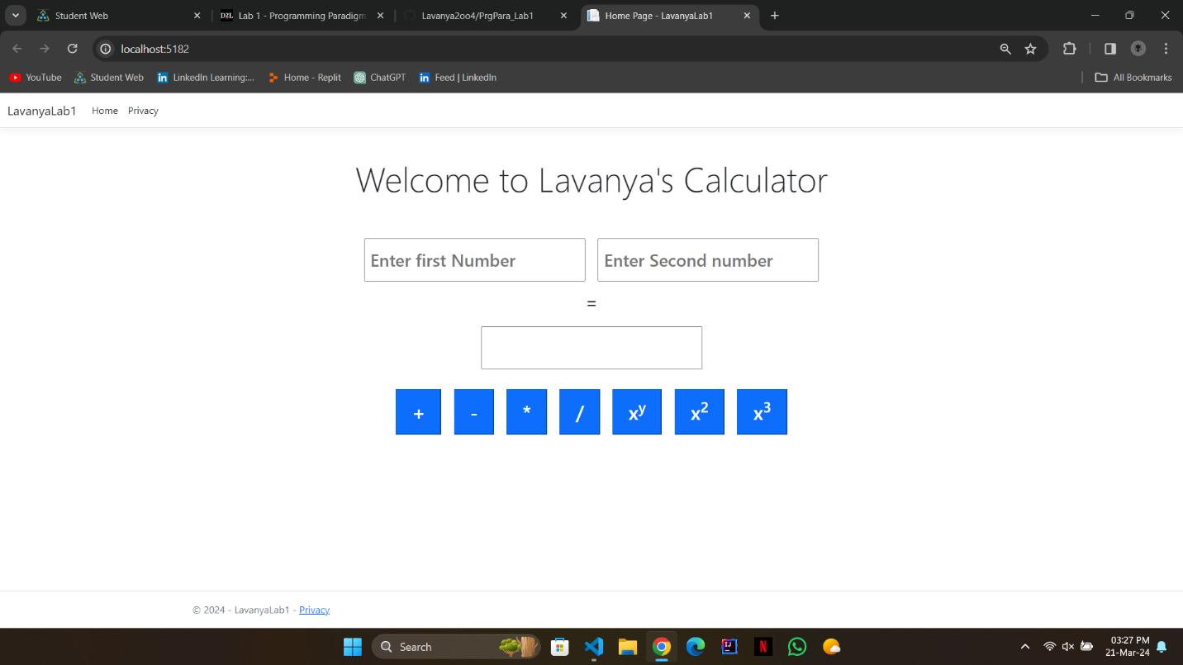

Figure 1:Created the Calculator

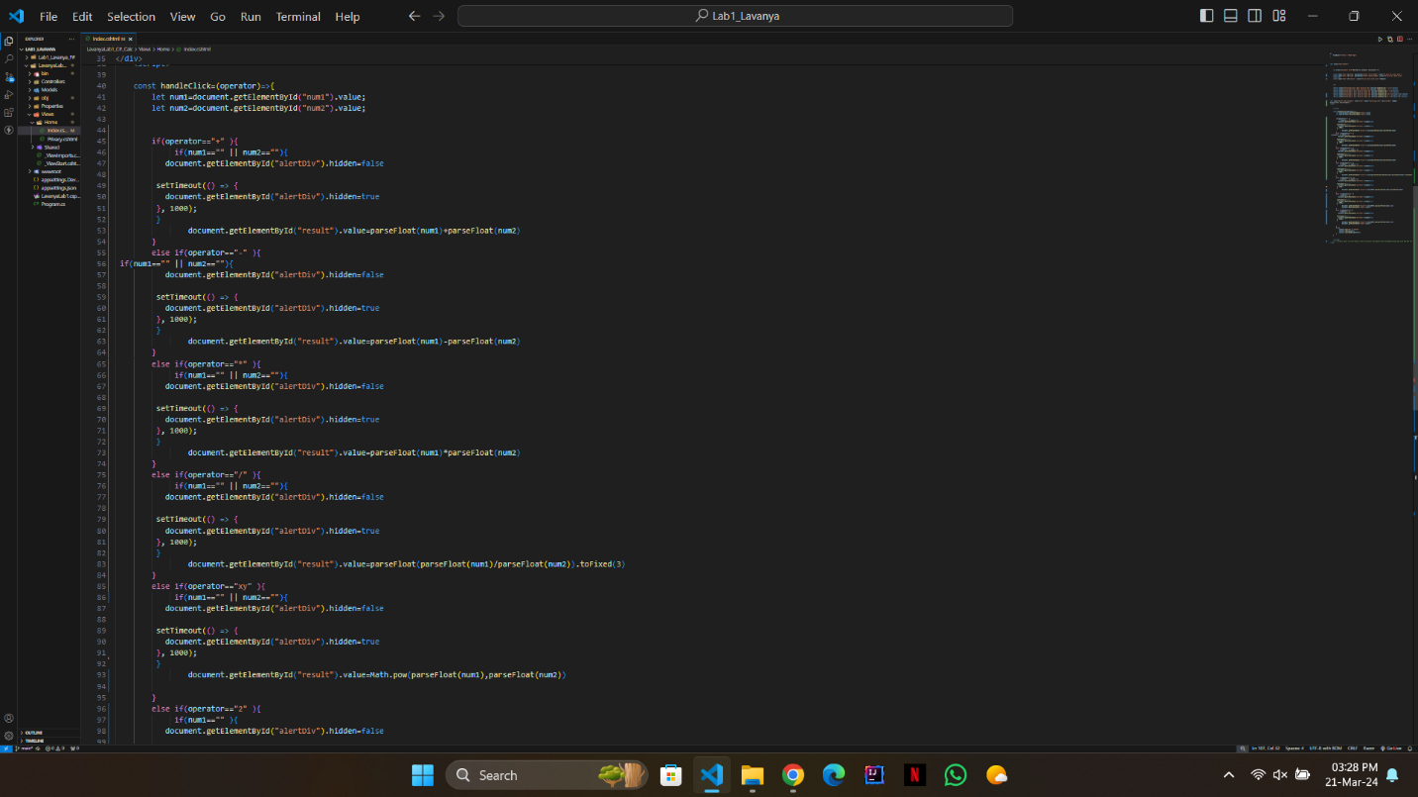

Figure 2:Calculator Code

## Step 2:

1. Write a program that uses tail recursion to process a list.

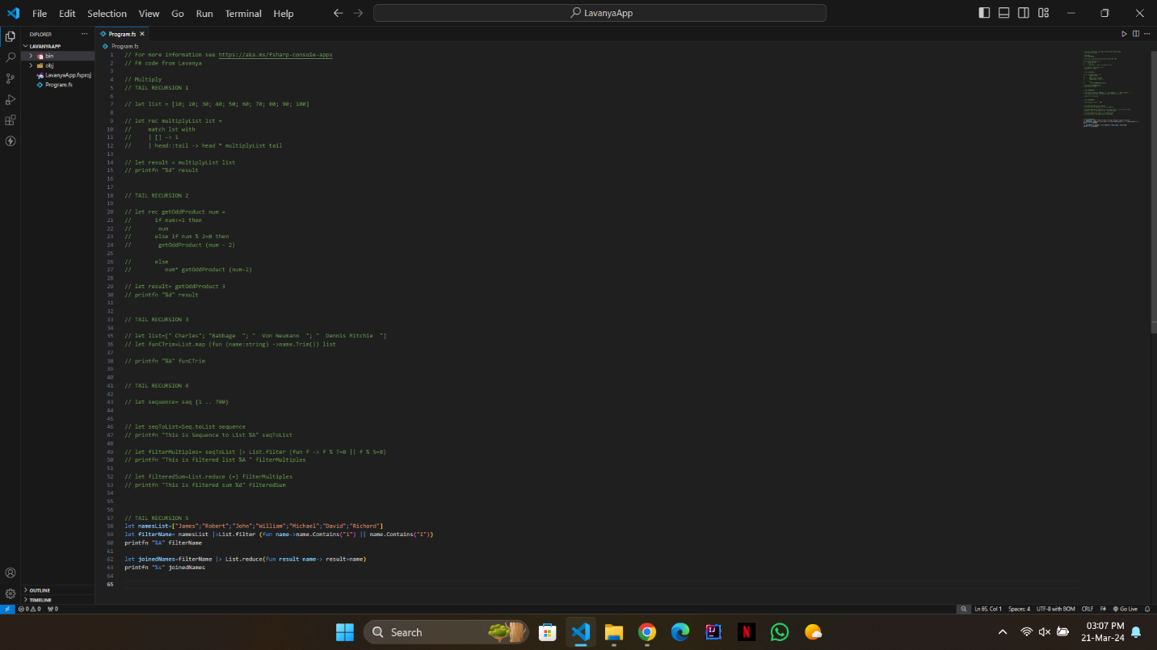

Figure 3:F# Code

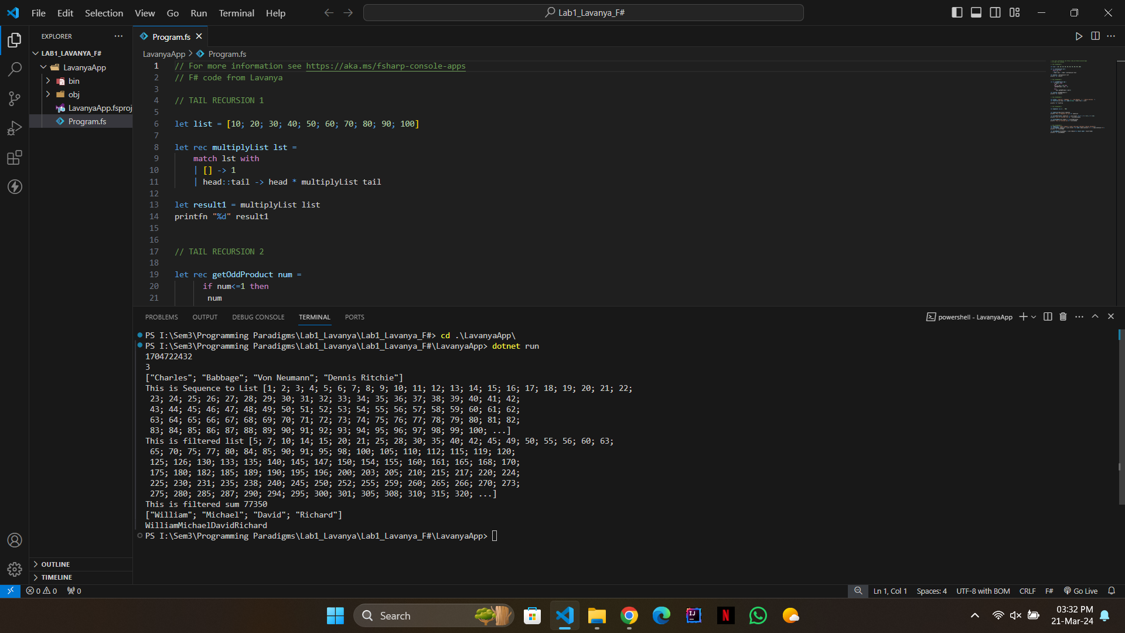

Figure 4:f# output